# Requirements – Student #3

Please, fill in the following form, make sure that you have ticked the requirements that you consider fulfilled, save this document, **and attach it in its original format (.docx)** to every deliverable. Regarding your ID, please keep only four random digits and mask the others using an asterisk. **Please, note that this document must be edited with the desktop version of Word since the web version does not properly support forms.** Attaching this document entails that you are the authors of the work delivered, you have not cheated in any way, and you have read and understood the information delivered regarding the subject, with a special emphasis on the methodological guidelines and how your work is going to be graded. Make sure that your project works well with the latest version of the development framework.

|  |
| --- |
| **Group:** C3.040 |
| **Repository:** https://github.com/DP2-C1-037/Acme-ANS-C3 |
| Student #3  **ID Number:** 2*5*13**M  **UVUS:**  JFC1183  **Name:**  Álvarez Raya, Miguel  **Roles:**  Manager, developer, tester |
| **Date:** Seville Oct 10, 2025 |

# MANDATORY Deliverable D01: introduction

## Information requirements

Intentionally blank.

## Functional requirements

1. Modify the anonymous menu so that it shows an option that takes the browser to the home page of your favourite web site. The title must read as follows: “〈id-number〉: 〈surname〉, 〈name〉”, where “〈id-number〉” denotes your DNI, NIE, or passport number, “〈surname〉” denotes your surname/s, and “〈name〉” denotes your name/s.

X

## Non-functional requirements

Intentionally blank.

## Testing requirements

Intentionally blank.

## Managerial requirements

1. Provide a link to your planning dashboard in GitHub to review the tasks, their current status, and your schedule.

X

# MANDATORY Deliverable D02: data models

## Information requirements

1. The **flight crew members** are the people responsible for operating aircrafts and ensuring passenger safety and comfort during a flight. The system must store the following data about them: an **employee code** (unique, pattern "^[A-Z]{2-3}\d{6}$", where the first two or three letters correspond to their initials), a **phone number** (pattern "^\+?\d{6,15}$"), their **language skills** (up to 255 characters), their **availability status** ("AVAILABLE", "ON VACATION", "ON LEAVE"), the **airline** they are working for, and their **salary**. Optionally, the system may store his or her **years of experience**.

X

1. A **flight assignment** represents the allocation of a **flight crew member** to a specific **leg** of a flight. Each assignment specifies the flight crew's **duty** in that leg ("PILOT", "CO-PILOT", "LEAD ATTENDANT", "CABIN ATTENDANT"), the **moment** of the last update (in the past), the **current status** of the assignment ("CONFIRMED", "PENDING", or "CANCELLED"), and some **remarks** (up to 255 characters), if necessary.

X

1. An **activity log** records incidents that occur during a flight. They are logged by any of the **flight crew members** assigned to the corresponding leg and after the **leg** has taken place. The incidents include weather-related disruptions, route deviations, passenger issues, or mechanical failures, to mention a few. Each log entry includes a **registration** **moment** (in the past), a **type of incident** (up to 50 characters) a **description** (up to 255 characters), and a **severity level** (ranging from 0 to 10, where 0 indicates no issue and 10 represents a highly critical situation).

X

## Functional requirements

Intentionally blank.

## Non-functional requirements

Intentionally blank.

## Testing requirements

1. Produce assorted sample data to test your application informally. The data must include four **flight crew** **member** accounts with credentials “**memberX**/**memberX**” with X ranging from 1 to 4 (and different duties each). Additionally, create a fifth member account **member/member**,representing a new member with no flight assignment, as if the account had just been created.

X

## Managerial requirements

1. Provide a link to your planning dashboard in GitHub to review the tasks, their current status, and your schedule.

X

# MANDATORY Deliverable D03: implementing features

## Information requirements

Intentionally blank.

## Functional requirements

1. Operations by **flight crew members** on **flight assignments**:

* List the flight assignments separately, one for completed flight legs and another one for those planned but that have not taken place yet.
* Show the details of their flight assignments and the associated legs and flight crew members.
* Create, update, and publish their flight assignments. Only crew members with duty “LEAD ATTENDANT” can perform these operations. Please, note that to publish a flight assignment these cannot be linked to legs that have already occurred. Additionally, only flight crew members with an "AVAILABLE" status can be assigned to a leg, and they cannot be assigned to multiple legs simultaneously. Lastly, each leg can only have one pilot and one co-pilot. The allocation of remaining roles for other flight crew members is at the discretion of the “LEAD ATTENDANT”. Flight assignments can be updated or deleted as long as they have not been published.

X

1. Operations by **flight crew members** on **activity log records**:

* List the activity log records in their flight assignments.
* Show the details of their activity log records.
* Create, update, delete and publish activity log records. They cannot be published if their corresponding flight assignments have not been published yet. No updating or deletion is possible once an activity log record has been published.

X Todo bien hasta que he intentado crear un log para un vuelo que ya había terminado y me ha saltado la siguiente excepción:

Ocurre lo mismo si intento crear un log para un flight assignment que ya está publicado y que ha pasado. Me ha vuelto a fallar:

Como se puede comprobar en la BD, el flight assignment 652 está publicado y no tiene logs:

Aquí paramos la evaluación.

**Comment – Student:**  
He intentado reproducir el error descrito, pero no he sido capaz de obtener la excepción indicada.

Para comprobarlo, he creado un *flight assignment* desde cero, asegurándome de que estuviera ya finalizado (estableciendo la fecha del sistema a un momento del pasado). A continuación, he intentado crear un *activity log* para ese *assignment*, utilizando una fecha posterior. El sistema ha aceptado el registro sin mostrar ningún error.

Adjunto una captura de la base de datos donde se puede comprobar que el *flight assignment* está publicado (primera captura), así como otra captura en la que se observa que el *activity log* ha sido creado correctamente (segunda captura).





En las siguientes capturas se verifica el correcto funcionamiento con la aplicación desplegada:

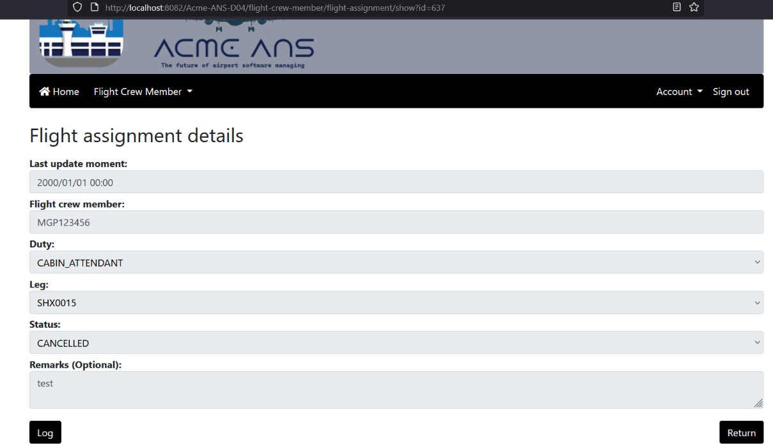

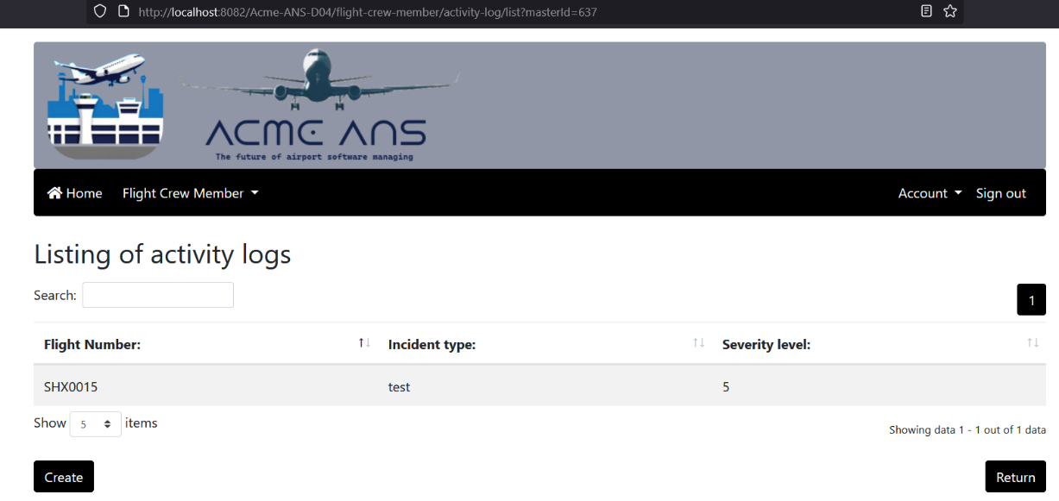

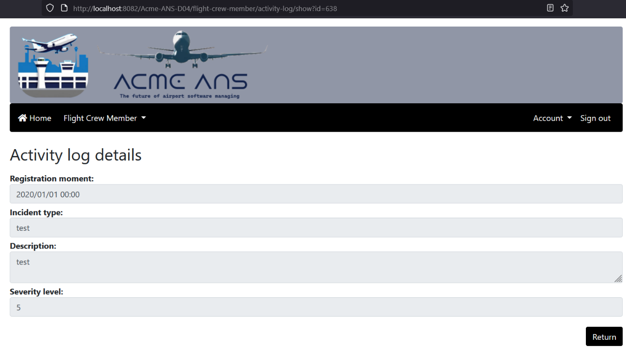

Agradecería, por tanto, una revisión de este punto, ya que no he podido replicar el comportamiento erróneo mencionado.

He vuelto a realizar las pruebas y, en efecto, había cometido un error. Simplemente, la excepción que se estaba lanzando se debía a que estaba modificando las fechas de una leg (para ponerla al pasado) pero esta leg pertenecía a un vuelo que tenía más de una leg. Los errores venían de que ahora el flight sería inconsistente debido al cambio que realicé en la BD. Lo he probado con otra leg que pertenecía a un flight que sólo tiene esa leg y el resultado es correcto. Sin embargo, al continuar la evaluación he comprobado que no puedo publicar una leg. Explico a continuación los pasos:

1. Me logueo como member/member y creo un flight assignment para la leg SHX0002

Busco en la BD qué id tiene ese member y tiene la cuenta de usuario con id = 13 y el id = 269 como miembro de la tripulación:

2. He filtrado en la BD para ver todos los flight assignments que tiene ese crew member y de momento solo tiene uno sin publicar, es decir, que está en modo draft y que yo acabo de crear:

Podemos ver que el flight assignment tiene el id = 640 y coincide con la entidad que estoy mostrando desde la interfaz:

Sin embargo, cuando hago clic en “Publish” aparece el siguiente error de validación:

Indica que el miembro de la tripulación tiene varias legs que se solapan, pero sólo tiene este flight assignment como he mostrado en la BD y como se puede ver en el siguiente listado:

Para que un flight assignment se pueda publicar, tiene que estar vinculado a una leg que no haya tenido lugar, lo cual se cumple, y que el miembro esté disponible, lo que también se cumple. Obviamente, una restricción implícita es que un miembro no puede estar asignado a varios vuelos que se solapen, independientemente del duty con el que estén asignados. Al tener un solo flight assignment debería de permitir su publicación, pero no lo permite. La BD está recién poblada con los datos de prueba. Lo único que he añadido es ese nuevo flight assignment. Paro aquí la revisión, porque no se puede publicar un flight assignment que debería de poder publicarse.

Comment – Student:

El fallo ocurría porque la lógica de validación, diseñada para evitar que un miembro de la tripulación tuviera asignaciones de vuelo solapadas en el tiempo, no excluía la propia asignación que se estaba intentando publicar. En consecuencia, el sistema la comparaba consigo misma, detectando incorrectamente un solapamiento inexistente.

La solución ha consistido en ajustar la consulta de validación. Ahora, al verificar si existen otras asignaciones para el mismo tripulante en un rango de fechas conflictivo, se ignora explícitamente la asignación de vuelo actual. De este modo, la validación funciona correctamente, permitiendo publicar una asignación única sin errores y previniendo los solapamientos reales con otras asignaciones distintas.

## Non-functional requirements

Intentionally blank.

## Testing requirements

Intentionally blank.

## Managerial requirements

1. Provide a link to your planning dashboard in GitHub to review the tasks, their current status, and your schedule.

X

# MANDATORY Deliverable D04: formal testing

## Information requirements

1. Create appropriate indices for your entities, if required.

X

## Functional requirements

Intentionally blank.

## Non-functional requirements

Intentionally blank.

## Testing requirements

1. Produce a test suite for Requirements #8 and #9.

X

## Managerial requirements

1. Provide a link to your planning dashboard in GitHub to review the tasks, their current status, and your schedule.

X

1. Produce a testing report.

X

# SUPPLEMENTARY I Deliverable D01: introduction

## Information requirements

Intentionally blank.

## Functional requirements

Intentionally blank.

## Non-functional requirements

Intentionally blank.

## Testing requirements

Intentionally blank.

## Managerial requirements

Intentionally blank.

# SUPPLEMENTARY I Deliverable D02: data models

## Information requirements

1. The system must handle **flight crew member** **dashboards** with the following **indicators**:

* The last five destinations to which they have been assigned.
* The number of legs that have an activity log record with an incident severity ranging from 0 up to 3, 4 up to 7, and 8 up to 10.
* The crew members who were assigned with him or her in their last leg.
* Their flight assignments grouped by their statuses.
* The average, minimum, maximum, and standard deviation of the number of flight assignments they had in the last month.

X

## Functional requirements

Intentionally blank.

## Non-functional requirements

Intentionally blank.

## Testing requirements

Intentionally blank.

## Managerial requirements

1. Produce a UML domain model regarding the information requirements in your project.

X

# SUPPLEMENTARY I Deliverable D03: implementing features

## Information requirements

Intentionally blank.

## Functional requirements

1. Operations by **anonymous principals** on user **accounts**:

* Sign up to the system and become a flight crew member.

X

1. Operations by **flight crew members** on **user accounts**:

* Update their profiles.

X

1. Operations by **any principals** on **flight assignments**:

* List the flight assignments that are published.
* Show the details of the flight assignments (excluding their activity logs).

X

1. Operations by **flight crew member** on **dashboards**:

* Show their flight crew member dashboards.

X

## Non-functional requirements

Intentionally blank.

## Testing requirements

Intentionally blank.

## Managerial requirements

1. Provide a link to a video in which you informally test requirement #8 and #9. Videos should not exceed 10 minutes in length and must be stored at the USE's facilities.

X

# SUPPLEMENTARY I Deliverable D04: formal testing

## Information requirements

Intentionally blank.

## Functional requirements

Intentionally blank.

## Non-functional requirements

Intentionally blank.

## Testing requirements

1. Perform five mutations in your code and report on the results.

## Managerial requirements

1. Produce a lint report.

# SUPPLEMENTARY II Deliverable D01: introduction

## Information requirements

Intentionally blank.

## Functional requirements

Intentionally blank.

## Non-functional requirements

Intentionally blank.

## Testing requirements

Intentionally blank.

## Managerial requirements

1. Produce an analysis report.

X

1. Produce a planning and progress report.

# SUPPLEMENTARY II Deliverable D02: data models

## Information requirements

1. The system is required to provide crew members with information about **visa requirements**. A web service must be used to populate this entity with information about visa requirements. Thus, the exact data to store depends on the chosen service, and it is the students' responsibility to define them accordingly. It is also the students’ responsibility to find the appropriate service; no implicit or explicit liabilities shall be covered by the University of Seville or their individual affiliates if the students hire pay-per-use services! The students are strongly advised to ensure that the service they choose is free of charge.

X

## Functional requirements

Intentionally blank.

## Non-functional requirements

Intentionally blank.

## Testing requirements

Intentionally blank.

## Managerial requirements

1. Produce an analysis report.

X

1. Produce a planning and progress report.

X

# SUPPLEMENTARY II Deliverable D03: implementing features

## Information requirements

Intentionally blank.

## Functional requirements

1. Operations by **flight crew members** on **visa requirements**:

* List visa requirements according to the destination countries of their flight assignments.
* Show the details of the visa requirements they can list.

1. Operations by **administrators** on **visa requirements**:

* Populate the database with visa requirements data.

## Non-functional requirements

Intentionally blank.

## Testing requirements

Intentionally blank.

## Managerial requirements

1. Produce an analysis report.

1. Produce a planning and progress report.

# SUPPLEMENTARY II Deliverable D04: formal testing

## Information requirements

Intentionally blank.

## Functional requirements

Intentionally blank.

## Non-functional requirements

Intentionally blank.

## Testing requirements

1. Produce as a complete test suite as possible for Requirement #29 ensuring that the web service is properly mocked.

## Managerial requirements

1. Produce an analysis report.

1. Produce a planning and progress report.